Deploying a java web application using tomcat
1) create a folder on desktop
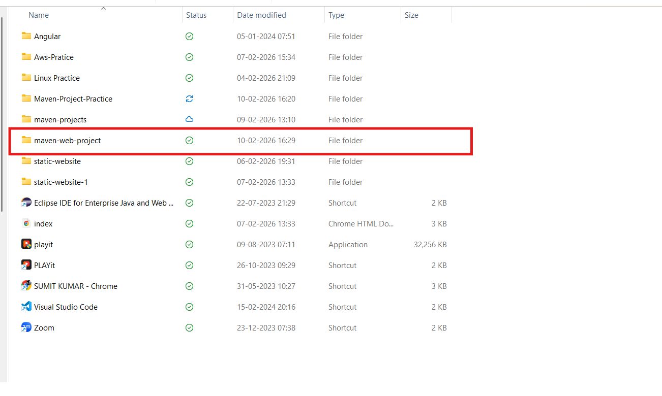
2) select that folder using vs code
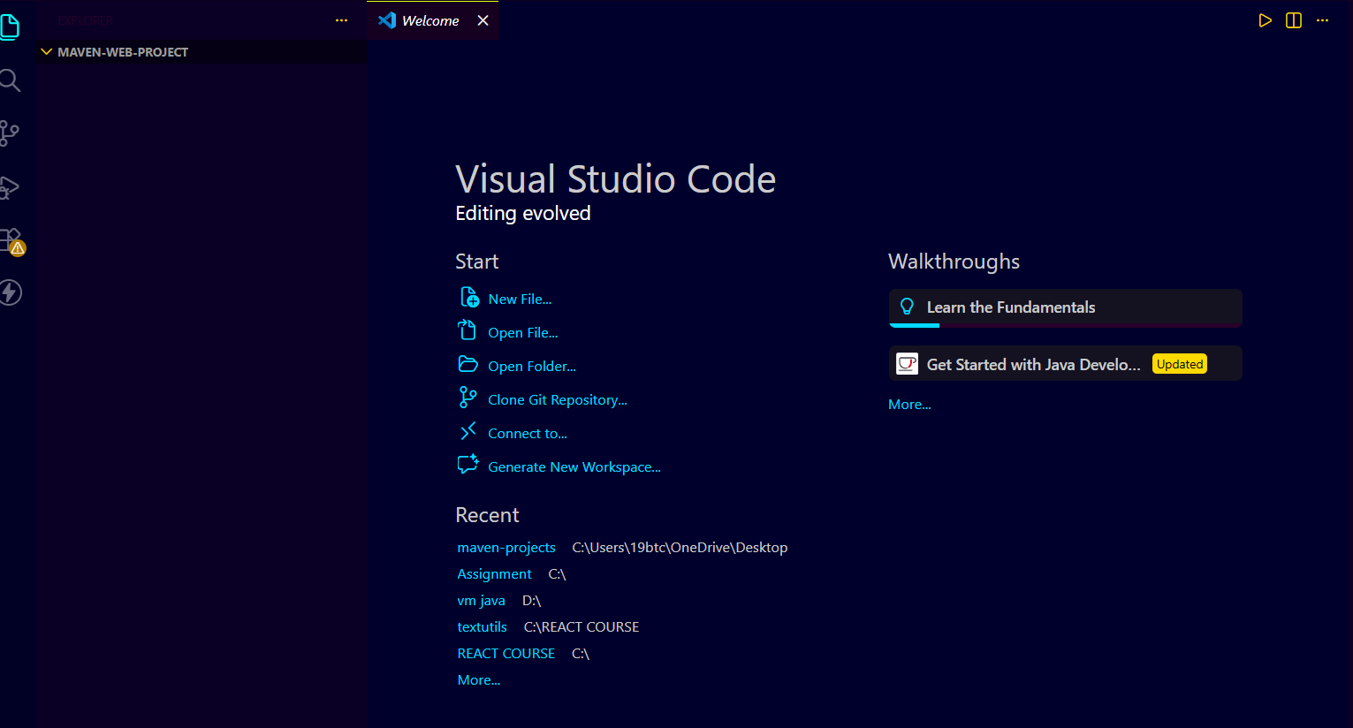

3) create a maven web app project
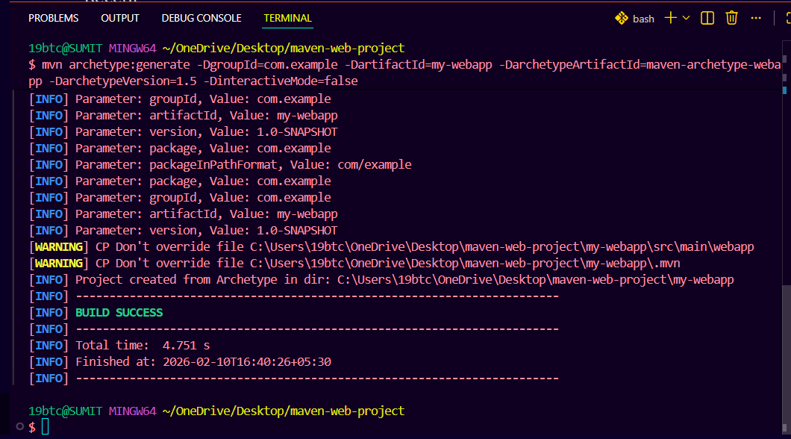
4) Add the content inside index.jsp
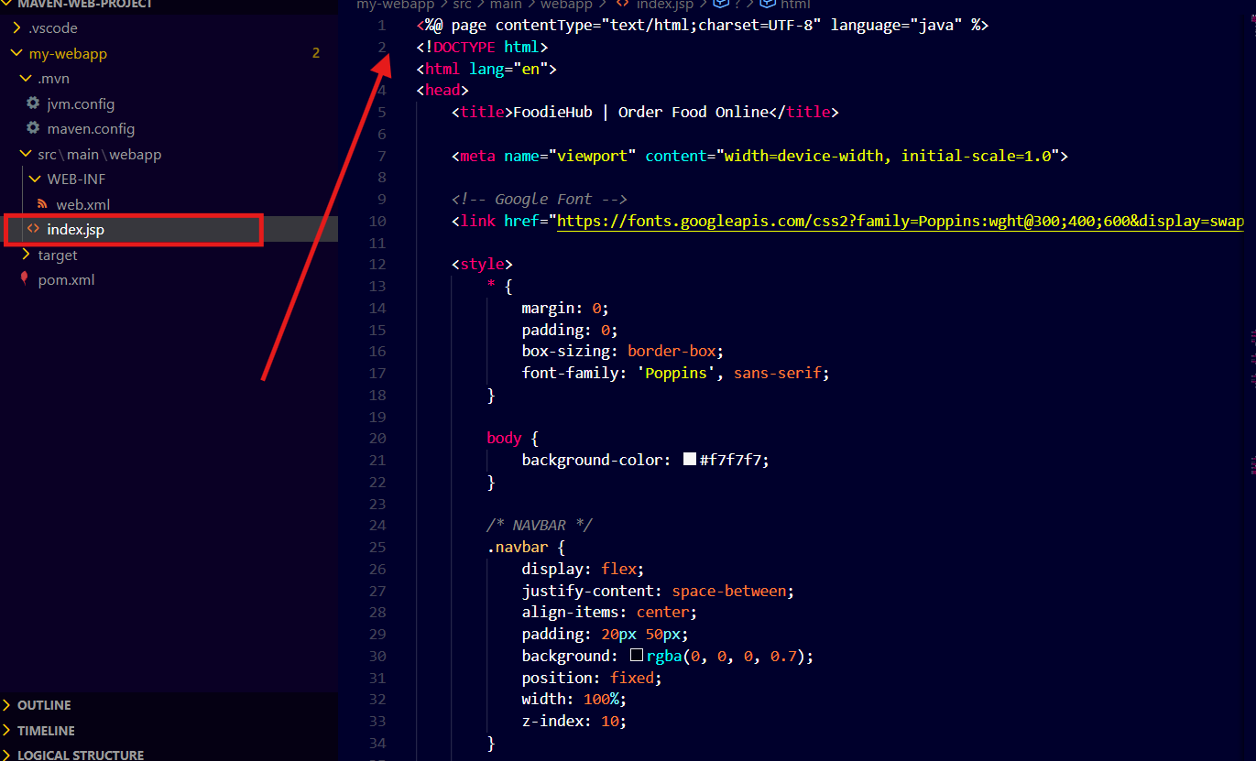

5) Add the dependencies inside pom.xml
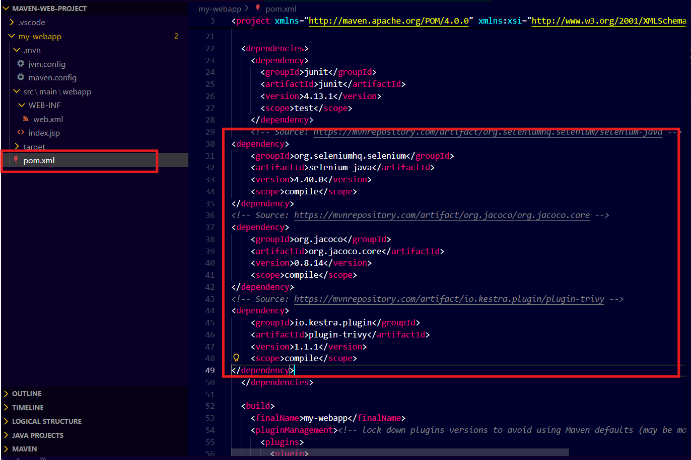
6) Compile the java code using maven compile goal
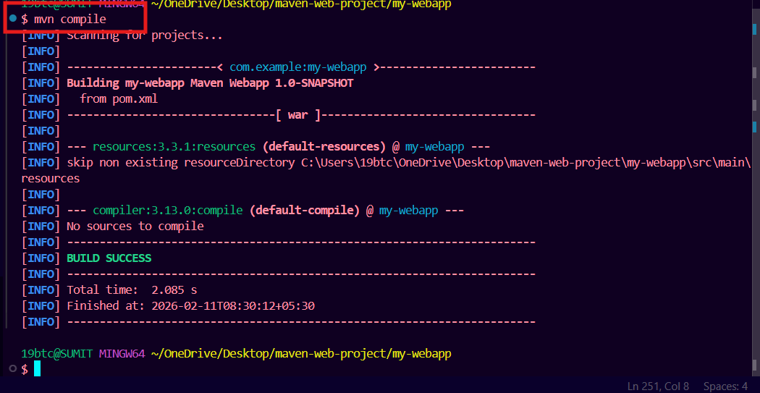

7) Test the java code using maven test goal
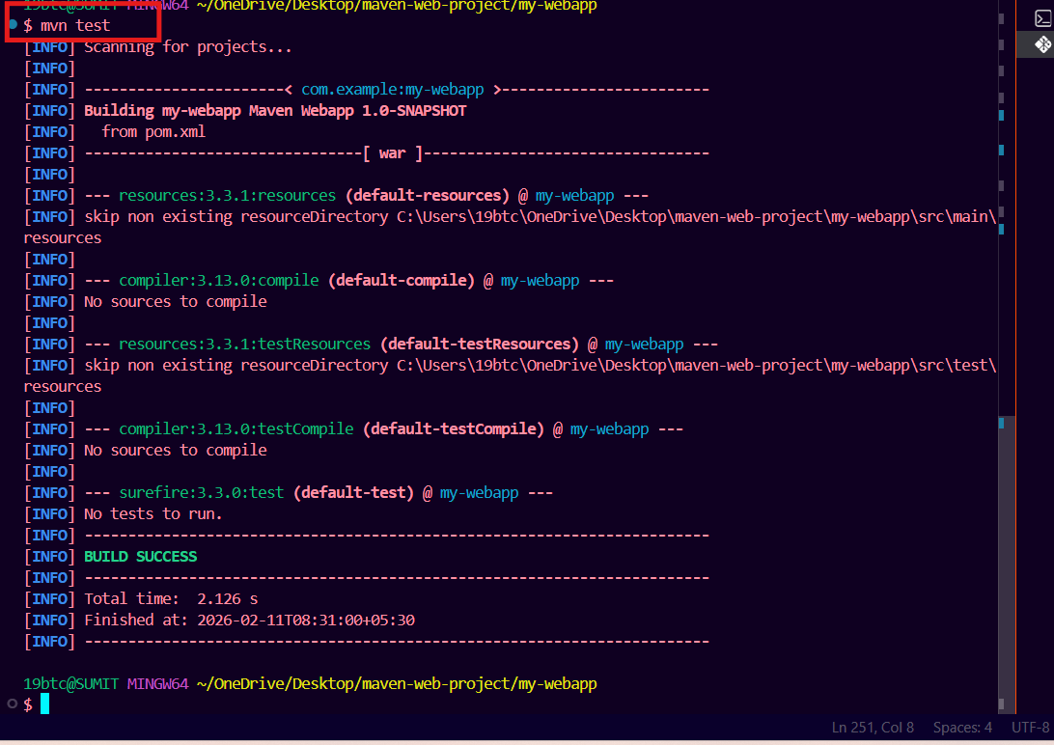

8) Package the java code using maven package goal
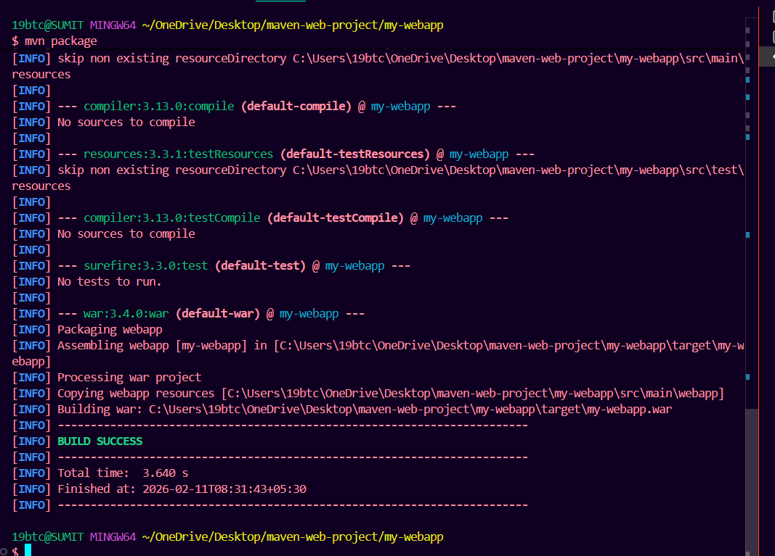

9) copy the .war file and paste it inside the tomcat webapps folder
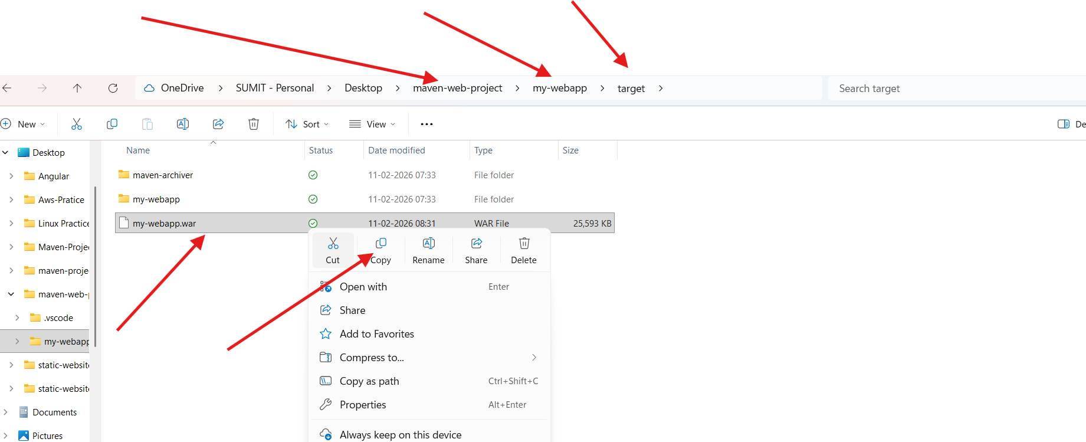
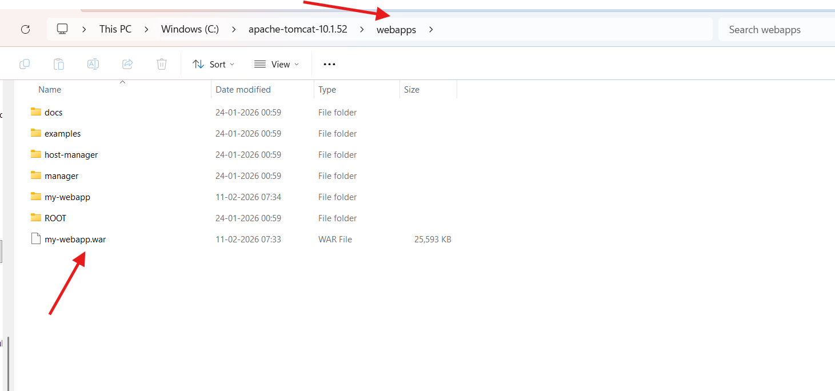
10) start the tomcat server using startup inside the bin folder
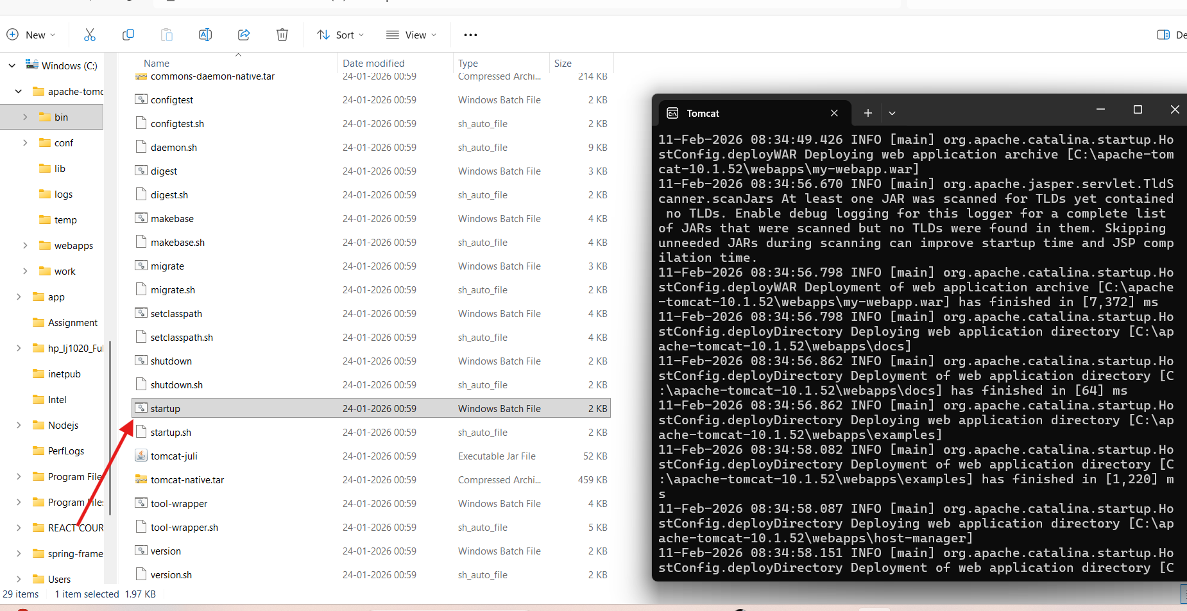

11) access the web application using localhost:8080/application_name

12) shutdown the tomcat server after practice using shutdown in bin folder
